# Assignment-4

PythonProgramming

|  |  |
| --- | --- |
| AssignmentDate | 26October2022 |
| StudentName | V.THARSINI |
| StudentRollNumber | 910619104094 |
| MaximumMarks | 2 Marks |

# Question-1:

Write code and connection sin wokwi for ultra sonic sensor.

Whenever distance is less than 100 cms send "alert" to ibm cloud and display in device recentevents.

Upload document with wokwi share link and images of ibm cloud.

NOTE: unable to access cloud.

# Solution:

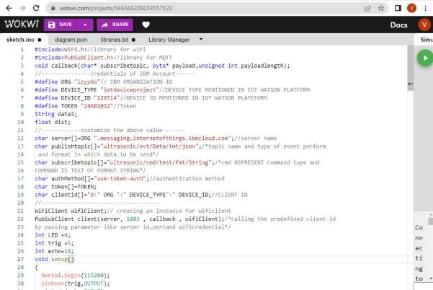

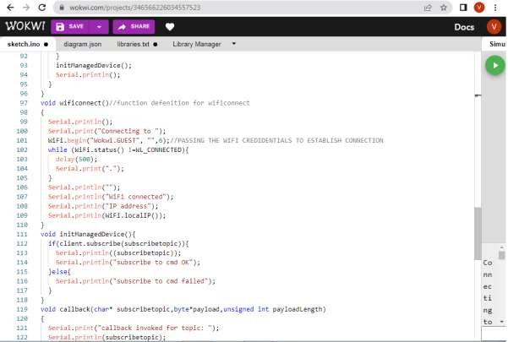

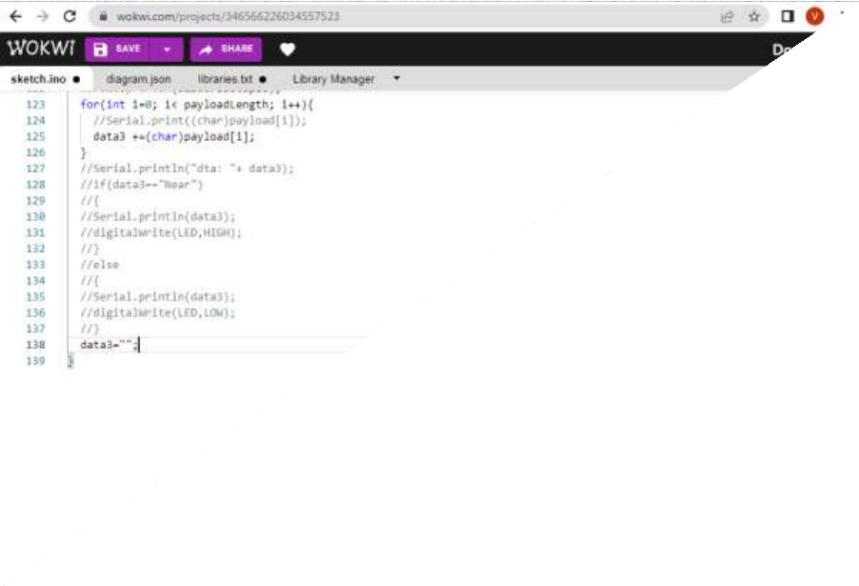

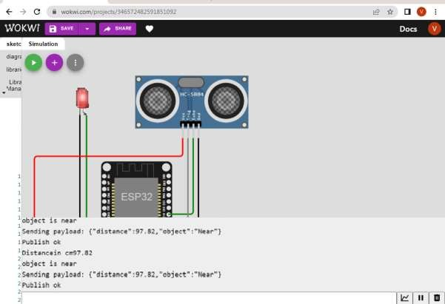Whenobjectis detected inultrasonic detector